Tutorial – 2

- Predict and write output for the following code.

namespace _24SOECE13901_SAURAV_PANDIT_TUTORIAL_2
{
internal class Q1
{
static void Main(string[] args)
{
/* local variable definition */
int a = 10;

/* check the boolean condition using if statement */
if (a < 20)
{
/* if condition is true then print the following */
Console.WriteLine("a is less than 20");
}
Console.WriteLine("value of a is : {0}", a);
Console.ReadLine();
}
}
}

Output:
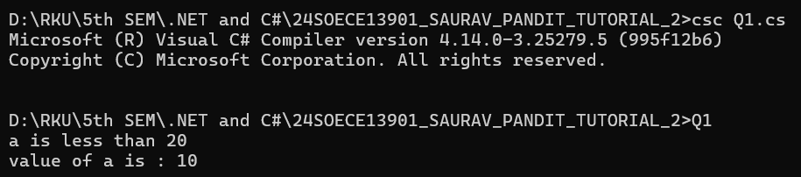

- Write missing statement to get the desired output.

namespace _24SOECE13901_SAURAV_PANDIT_TUTORIAL_2
{
internal class Q2
{
static void Main(string[] args)

{
/* local variable definition */
int a = 100;

/* check the boolean condition */
if (a < 20)
{
/* if condition is true then print the following */
Console.WriteLine("a is less than 20");
}
else
{
/* if condition is false then print the following */
Console.WriteLine("a is not less than 20"); // Missing statement-1
}
Console.WriteLine("value of a is : {0}", a); // Missing statement-2
Console.ReadLine();
}
}

Output:

- Correct the following code and write output for the corrected code.

namespace _24SOECE13901_SAURAV_PANDIT_TUTORIAL_2
{
internal class Q3
{
static void Main(string[] args)
{
string firstName = "John";
string lastName = "Doe";
Console.WriteLine("Name: " + firstName + " " + lastName);
Console.WriteLine("Please enter a new first name:");
firstName = Console.ReadLine();
Console.WriteLine("New name: " + firstName + " " + lastName);
Console.ReadLine();
}
}

Output:
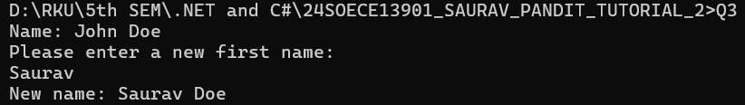

- Input two number A and B. perform different operations using different operators and different data types available in C#. (Note : Follow all the operators and data types to do above task. Use Online help whenever necessary.)

namespace _24SOECE13901_SAURAV_PANDIT_TUTORIAL_2
{
internal class Q4
{
static void Main(string[] args)
{
Console.Write("Enter number A: ");
int A = Convert.ToInt32(Console.ReadLine());

Console.Write("Enter number B: ");
int B = Convert.ToInt32(Console.ReadLine());

Console.WriteLine("\n=== Arithmetic Operators ===");
Console.WriteLine("A + B = " + (A + B));
Console.WriteLine("A - B = " + (A - B));
Console.WriteLine("A * B = " + (A * B));

Console.WriteLine("A / B = " + ((double)A / B));

Console.WriteLine("\n=== Relational Operators ===");
Console.WriteLine("A > B : " + (A > B));
Console.WriteLine("A == B : " + (A == B));

Console.WriteLine("\n=== Logical Operator ===");
Console.WriteLine("A>0 && B>0 : " + (A > 0 && B > 0));

Console.WriteLine("\n=== Bitwise Operator ===");
Console.WriteLine("A & B = " + (A & B));

Console.WriteLine("\n=== Other Data Types ===");
double d = (double)A / B;

Console.WriteLine("Double division: " + d);
string str = "Numbers: " + A + " and " + B;
Console.WriteLine("String example: " + str);

bool flag = (A == B);
Console.WriteLine("Boolean example (A==B): " + flag);
Console.ReadLine();
}
}
}

Output:
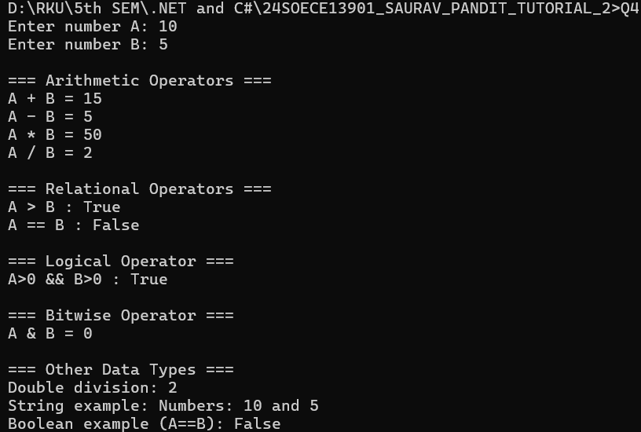

- Rearrange the given code to correct the program. The resultant program will be to enter 5 elements into an array and print sum of these elements.

namespace _24SOECE13901_SAURAV_PANDIT_TUTORIAL_2

{
internal class Q5

{
static void Main(string[] args)
{
int[] arr = new int[5];
int sum = 0;

for (int i = 0; i < 5; i++)
{
Console.Write("Enter Element {0}: ", i + 1);
string str = Console.ReadLine();
arr[i] = Convert.ToInt32(str);
}

for (int i = 0; i < 5; i++)
{
sum = sum + arr[i];
}

Console.WriteLine("Sum of Elements : {0}", sum);
Console.ReadLine();
}
}
}

Output:
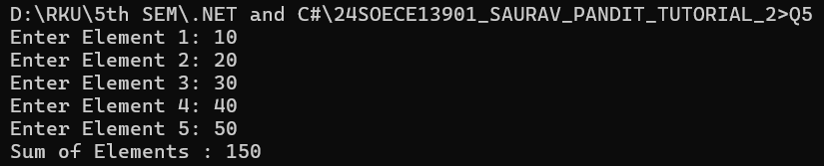

- Write missing statement to get the desired output.

namespace _24SOECE13901_SAURAV_PANDIT_TUTORIAL_2
{
internal class Q6
{

static void Main(string[] args)
{
Console.WriteLine("Hello, World!");

Console.WriteLine("You entered the following {0} command line arguments:",args.Length);

for (int i = 0; i < args.Length; i++) // Missing statement-1
{ // Missing statement-2
Console.WriteLine(args[i]); // Missing statement-3
} // Missing statement-4
}
}
}

Output:
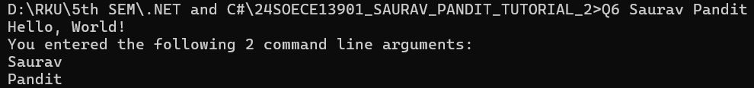

- Predict and write the output of the given code.

namespace _24SOECE13901_SAURAV_PANDIT_TUTORIAL_2
{
internal class Q7
{
public void swap(ref int x, ref int y)
{
int temp;
temp = x; /* save the value of x */
x = y; /* put y into x */
y = temp; /* put temp into y */
}
}
class TestRef
{
static void Main(string[] args)
{
Q7 n = new Q7();
/* local variable definition */
int a = 100;
int b = 200;

Console.WriteLine("Before swap, value of a : {0}", a);
Console.WriteLine("Before swap, value of b : {0}", b);

/* calling a function to swap the values */

n.swap(ref a, ref b);
Console.WriteLine("After swap, value of a : {0}", a);
Console.WriteLine("After swap, value of b : {0}", b);
Console.ReadLine();
}
}
}

Output:
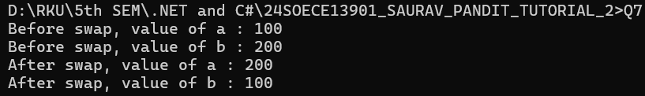

- Find out error code and correct it. Write the output of the corrected code.

namespace _24SOECE13901_SAURAV_PANDIT_TUTORIAL_2
{
internal class Q8
{
public int getValues(out int x, out int y, out int z)
{
Console.WriteLine("Enter the first value: ");
x = Convert.ToInt32(Console.ReadLine());

Console.WriteLine("Enter the second value: ");
y = Convert.ToInt32(Console.ReadLine());

Console.WriteLine("Enter the third value: ");
z = Convert.ToInt32(Console.ReadLine());

int sum = x + y + z;
return sum;
}
}

class TestOut
{
static void Main(string[] args)

{
Q8 n = new Q8();

int a, b, c, sum;
sum = n.getValues(out a, out b, out c);
Console.WriteLine("After method call, value of a : {0}", a);
Console.WriteLine("After method call, value of b : {0}", b);
Console.WriteLine("After method call, value of c : {0}", c);
Console.WriteLine("Sum : {0}", sum);
Console.ReadLine();
}
}
}

Output:
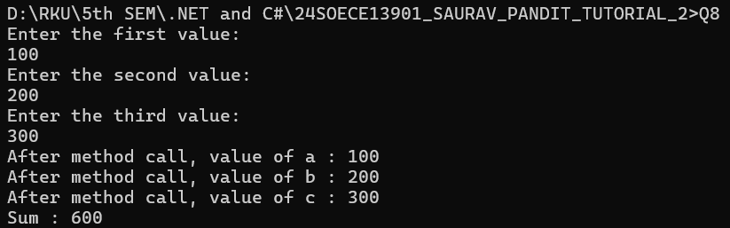

- Given an array A containing 2*N+2 positive numbers, out of which 2*N numbers exist in pairs whereas the other two number occur exactly once and are distinct. Find the other two numbers.

namespace _24SOECE13901_SAURAV_PANDIT_TUTORIAL_2
{
internal class Q9
{
static void UniqueNumber(int[] arr)
{
int xor = 0;
foreach (int num in arr)
xor ^= num;

// Find rightmost set bit

int rightmostSetBit = xor & -xor;

int num1 = 0, num2 = 0;

foreach (int num in arr)
{
if ((num & rightmostSetBit) != 0)
num1 ^= num;
else
num2 ^= num;
}

Console.WriteLine(num1 + " " + num2);
}

static void Main(string[] args)
{
int[] arr1 = { 1, 2, 3, 2, 1, 4 };
Console.Write("Output for Example 1: ");
UniqueNumber(arr1);

int[] arr2 = { 2, 1, 3, 2 };
Console.Write("Output for Example 2: ");
UniqueNumber(arr2);

Console.ReadLine();
}
}
}

Output:

- Given a matrix mat[][] of size N x M, where every row and column is sorted in increasing order, and a number X is given. The task is to find whether element X is present in the matrix or not.

namespace _24SOECE13901_SAURAV_PANDIT_TUTORIAL_2

{
internal class Q10
{
static bool SearchMatrix(int[,] mat, int n, int m, int x)

{
int row = 0; // start from top-right corner
int col = m - 1;

while (row < n && col >= 0)
{
if (mat[row, col] == x)
return true;
else if (mat[row, col] > x)
col--;
else
row++;
}
return false;
}

static void Main()
{
int[,] mat = {
{ 10, 20, 30, 40 },
{ 15, 25, 35, 45 },
{ 27, 29, 37, 48 },
{ 32, 33, 39, 50 }
};

int n = mat.GetLength(0);
int m = mat.GetLength(1);

Console.Write("Enter element to search: ");
int x = int.Parse(Console.ReadLine());

if (SearchMatrix(mat, n, m, x))
Console.WriteLine("Element {0} is present in matrix.", x);
else
Console.WriteLine("Element {0} is NOT present in matrix.", x);
}
}

}

Output:
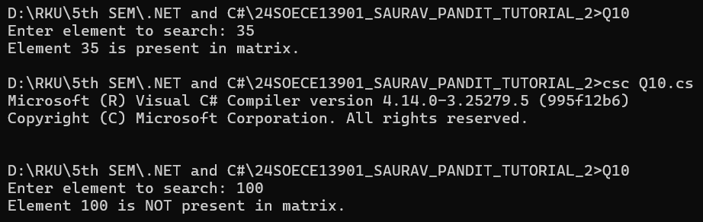

- Write a program to find the sum of N elements of an Array.

namespace _24SOECE13901_SAURAV_PANDIT_TUTORIAL_2
{
internal class Q11
{
static void Main(string[] args)
{
Console.Write("Enter number of elements: ");
int n = Convert.ToInt32(Console.ReadLine());

int[] arr = new int[n];
int sum = 0;

for (int i = 0; i < n; i++)
{
Console.Write("Enter element {0}: ", i + 1);
arr[i] = Convert.ToInt32(Console.ReadLine());
sum += arr[i];
}

Console.WriteLine("Sum of array elements = " + sum);

Console.ReadLine();
}
}
}

Output:
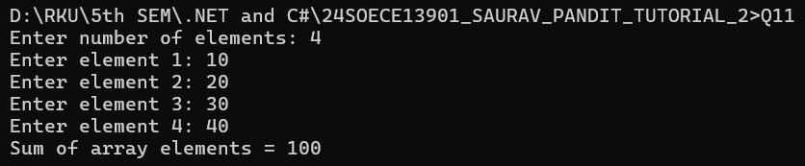

- Write a program to find the element from an Array and print 1 if element is found else
print 0.

namespace _24SOECE13901_SAURAV_PANDIT_TUTORIAL_2
{
internal class Q12
{
static void Main()
{
Console.Write("Enter size of array: ");
int n = int.Parse(Console.ReadLine());

int[] arr = new int[n];

Console.WriteLine("Enter array elements:");
for (int i = 0; i < n; i++)
{
arr[i] = int.Parse(Console.ReadLine());
}

Console.Write("Enter element to search: ");
int x = int.Parse(Console.ReadLine());

bool found = false;

// Linear Search
for (int i = 0; i < n; i++)
{
if (arr[i] == x)
{
found = true;

break;
}
}

if (found)
Console.WriteLine("1"); // Element found
else
Console.WriteLine("0"); // Element not found
}
}
}

Output:
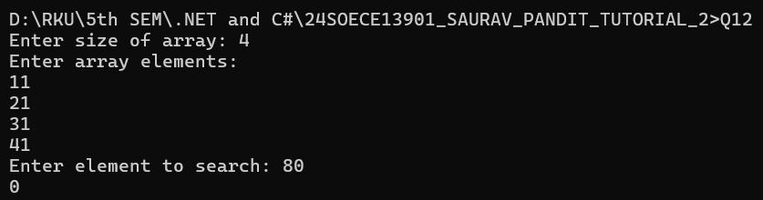

- Write a Program that will accept the amount and find how many minimum no of notes you required for that.
(Using the rupee notes of 1,2,5,10,20,50,100,500,2000)

namespace _24SOECE13901_SAURAV_PANDIT_TUTORIAL_2
{
internal class Q13
{
static void Main()
{
Console.Write("Enter the amount: ");
int amount = int.Parse(Console.ReadLine());

int[] notes = { 2000, 500, 200, 100, 50, 20, 10, 5, 2, 1 };

foreach (int note in notes)
{
int count = amount / note; // how many notes of this type
amount = amount % note; // remaining amount

Console.WriteLine("Notes of Rs.{0} = {1}", note, count);
}
}
}
}

Output:
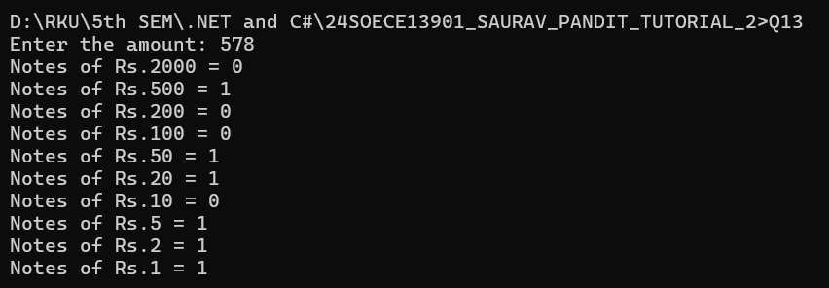

- Write a Program to find the eligibility of admission for a professional course
based on the following criteria:

namespace _24SOECE13901_SAURAV_PANDIT_TUTORIAL_2
{
internal class Q14
{
static void Main()
{
Console.Write("Input the marks obtained in Maths: ");
int maths = int.Parse(Console.ReadLine());

Console.Write("Input the marks obtained in Physics: ");
int physics = int.Parse(Console.ReadLine());

Console.Write("Input the marks obtained in Chemistry: ");
int chemistry = int.Parse(Console.ReadLine());

int total = maths + physics + chemistry;
int mpTotal = maths + physics;

if (maths >= 65 && physics >= 55 && chemistry >= 50 &&
(total >= 180 || mpTotal >= 140))
{
Console.WriteLine("The candidate is eligible for admission.");
}
else
{
Console.WriteLine("The candidate is not eligible for admission.");
}
}
}
}

Output:

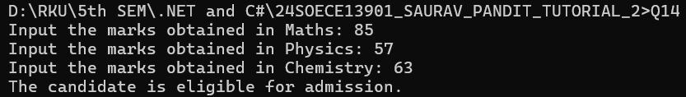

- Write a Program which accepts name from the user and prints the same.

namespace _24SOECE13901_SAURAV_PANDIT_TUTORIAL_2
{
internal class Q15
{
static void Main()
{
Console.Write("Enter your name: ");
string name = Console.ReadLine();

Console.WriteLine("You entered: " + name);
}
}
}

Output:

